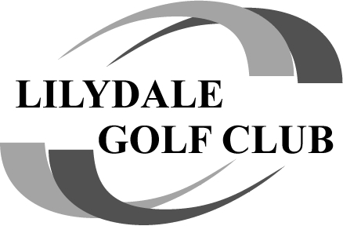

Bayviews also saw the 2023 trophies handed out to the winners

**Club Champion**

Congratulations to the Pres who won the Fraser McDonald Shield Club Champion for season 2023. Was the closest finish we have had in years, just ahead of Matt Scott… and yes all scores were double checked!

Jay Callow – A Grade

Warren Sidebottom – B Grade

Matt Scott – C Grade

**Lilydale Plate**

Well done to Matt Scott who won the 2023 Lilydale plate (Stroke event) by 1 shot over Mark Rowe

**Match Play**

Well done to Neal “Chappy” Champman who won the match play final at the last game at Devilbend over the Pres. Chappy now a 2 time winner!

**Order of Merit**

Well done to the Pres for winning the Order of merit (helps when you play all games 😊) by 18pts over Alex Clarkson. The Pres now a 2 time OOM winner.

**Lilydale Cup**

Well done to the Left Overs, going back to back to win the final by 2 pts 83-81 over smashing birdies. Can they do a 3 peat??

**MVP**

Well done to Matt Scott for taking out the 2023 MVP winning by 2 votes. (needed a wheelbarrow to take it all home!!)

**NAGA**

Yep, we have a 4 time NAGA trophy winner, Kenny G salutes again… don’t worry Kenny, at least you won something 😊

Good luck to all for the 2024 season, I’m sure we will see a few new names up here at the end of this season!