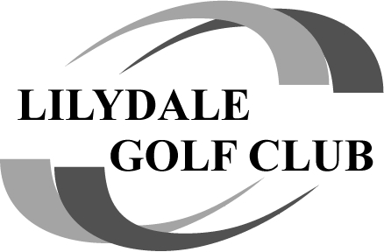

**TB OR NOT TB AT COBRAM....**

**YES IT WAS TB........**

**Well 24 Lilydale Club & Former Club Members made the trip north to Cobram Barooga Golf Club for another wonderful weekend of golf, discussion & frivolity........It was great to catch up with some former Members on the weekend namely, Ed Farrell, Jim Karvellas & “Bluey” Boorer.**

**We started on the West Course on Saturday after abit of confusion with the Pro Shop....a nice day with the course in very good condition. What a great setup there at Barooga with the motel right across the road from the course. Easy access for all.**

**Well Saturdays' results saw that “ever popular” (because everybody talks about him...!!) Member TB take the honours with 35 pts, just ahead of Matty Scott on 34 and third was The Pres also on 34 pts. CCR was 32. A couple of the guys had a “practice” hit on the Friday and they warned us about the Pin Positions and difficulty with putting....and they were SPOT ON.....pin positions on the side of slopes a common feature for most greens.**

**NTP's for the day saw Colin P go the closest on the 8th with 1.07m, just shaving TB who had close one on the 6th with his second shot which landed 1.09m from the pin. Well done to all of the NTP winners on the day. The Longest Drives went to “A”   Tony Valena...with a MONSTER DRIVE....I heard one or more Members were quite pleased when they reached TV's marker with their SECOND SHOT....!!!! “B” went to Trevor Scutt with “C” taken out by Chris Taylor. The Over 65's saw “Darky” Rowe take the honours, and with the Over 77's unfortunately no winner there as the ball was just off the fairway......!!!!!**

**Only 2 Birdies on the day....TB & Colin P.......**

**NAGA went to Peter Mol with 17 pts...you cant take a trick Pete at Cobram...last year sick from drinking the water on the course and this year the “Pinkie”....it can only get better mate......!!!! But Peter was the Gameday Sponsor & gave all participating Members a new Orange ball as well as donating a bag of goodies to the top 3 prize winners on the day.....Well done to you Peter and “THE GORILLA”......**

**On the Sunday the Ambrose Team Event was held on the Old course.**

**Winners with 59.5 (5 under off the stick) was Colin P, TB, Tony V & Dom Lostitch, (the red hot favourites who were a steal at the action!)  second place saw Chappy, Darky Rowe, Matt Scott & Trev S take the honours with 61 and TEAM “Zero LD” (OLD) Ed, Bluey, Jock & Wally finished third with 61.5.**

**NTP's closest was Bluey with a 1.7m on the 5th, with Clarkey, Jono & Ed getting prizes as well.**

**Well done to all of the Prize winners.**

**Lilydale Cup results saw TRex def Wish We Could 78-68, Leftovers def Smaka 88-87 & No Shows def Saint Tigers 88-72. The ladder is on top Trex on 16 pts, Leftovers on 12 & Smaka on 8.**

**Trex has locked in a grand final berth after the win, with their opponent to be either Left Overs or Smaka…. Will find out after Garfield 😊**

**Milestones, Chappie played his 150th game & Trev Scutt played his 50th game. Well done boys, great effort.**

**A special thanks to The Pres for the total organising of the trip to Cobram- Barooga. It all ran very well.....Back again next year.....????**

**Next game is on October 27th at Garfield with 2 Tee start at 8.30am.**

**Also on that day I have had a whisper that a couple of “Older” Members will pay us a visit (not playing) to say hello......will be great to see them again after a lot of years......**

**And not one for mentioning names BUT who was the Member whilst relieving himself under a tree on course, was attacked by a magpie, and tried to scare it off by pointing a “free flowing Percy” at it, only to wet his his pants.......Lesson learnt....!!!!**

**And finally......**

**Say what you will about women BUT I think being able to turn one sentence into a six hour argument takes talent.....and, The sales guy at Harvey Norman told me the sofa would seat 5 people without any problems.Then it occurred to me, I don't think I know 5 people without any problems.....**

**See you all at Garfield.**